

**END OF TERM ONE EXAMINATIONS 2023**

**MIDDLE CLASS**

**LANGUAGE DEVELOPMENT ONE**

NAME_________________________________________

1. **Match the same and write**.

cup box

moon tin

mat cup

sun moon

tin mat

box sun

1. **Colour the picture**.
2. **Name the pictures**.

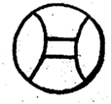

ball

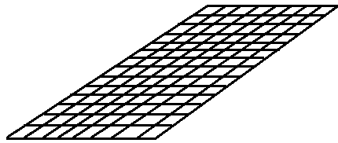

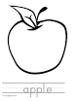

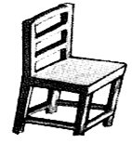

1. **Match pictures to words**.

hat

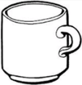car

tin

box

cup

sun

1. **Fill in the missing letters**.

a b

a b

a b c

a b c d

a b c d e

a b c d e f

1. **Copy the same.**

|  |  |  |  |  |
| --- | --- | --- | --- | --- |
| a | b | c | d | e |
|  |  |  |  |  |

1. **Trace the picture**.